Filtering Observations

It is often useful to work with a subset of the data based upon criteria other than the series in which the data resides, e.g. magnitude or time range, observer code, or some combination.

VStar has four mechanisms by which to create a filtered subset:

- The simple observation filter dialog (View → Simple Filter...).
- Creation of a filter from the current plot view (View → Filter From Plot).
- An Observation List selection filter (Create Selection Filter button).
- The VeLa filter dialog (View → VeLa Filter...).
- Custom observation filter plug-ins.

Consider the following W UMa observations:

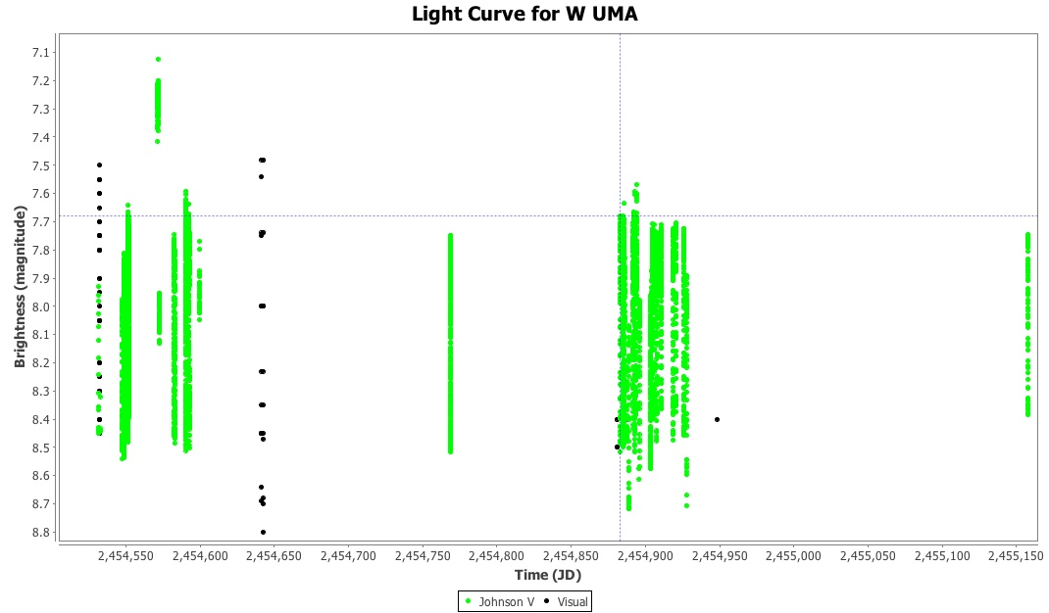

Notice that the cross-hairs are on an observation at the leftmost time extent of a particular block of Johnson V observations.
Selecting View → Simple Filter... or the corresponding toolbar button opens the Observation Filter Dialog.

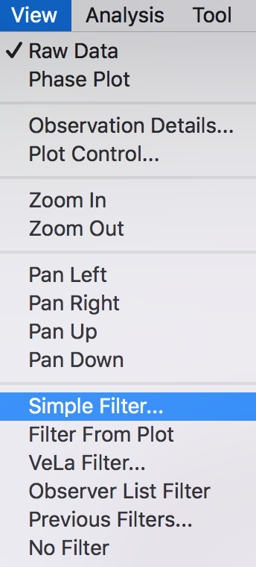

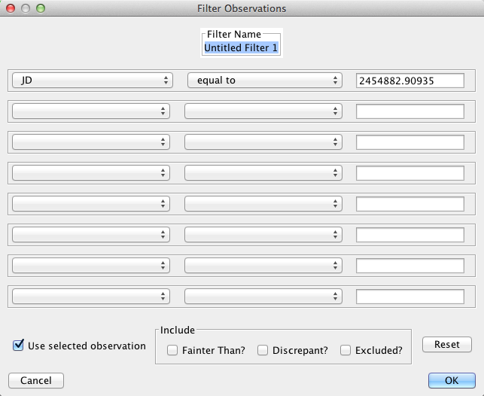
Here, “Use selected observation” has been checked such that when JD (Julian Day) is selected from a drop-down field menu, the text box is populated with the JD of the selected observation (under the cross-hairs). Selecting “greater than or equal” from the middle drop-down menu then dismissing the dialog with the OK button yields the following:

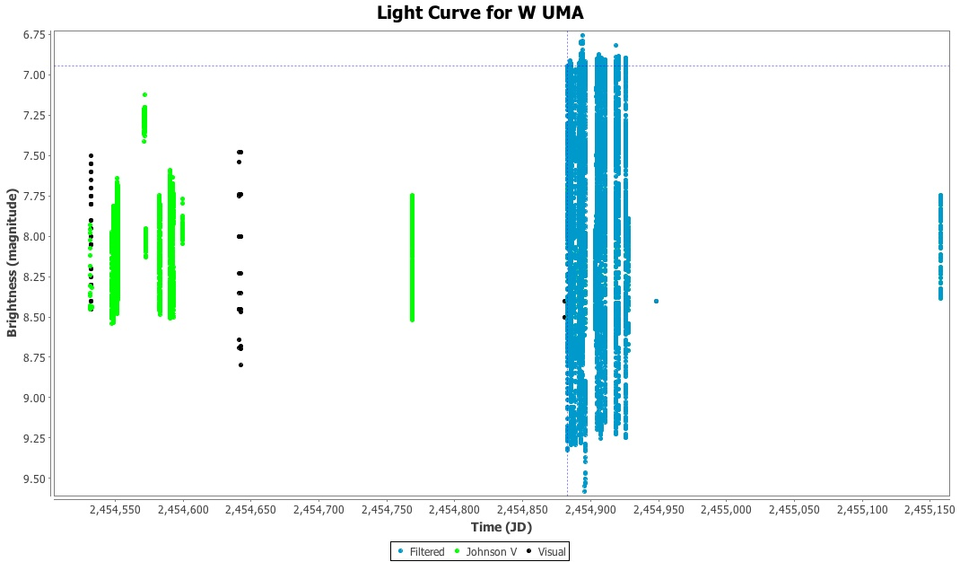

Notice that all observations with JDs greater than or equal to the selected observation are shown as being in the Filtered series (see legend at bottom of plot), regardless of series.

This filter could be refined to restrict the JD range and series included. The following example creates a filtered subset of observations where the JD is greater than or equal to 2454880 and the JD is less than or equal to 2454930, and the band is Johnson V. Operators differ with field type:

- For numeric fields such as JD, magnitude, and error, the usual relational operators are provided (equal, not equal, less than, greater than, less than or equal, greater than or equal).
- For string fields such as observer code or object name, equal and not equal are permitted.

The constrained filter mentioned above and the resulting observation plot are shown below.

Notice the implicit “AND”s represented by the filter dialog selections. Currently, 8 such “conjunctive” terms are permitted in a single filter.

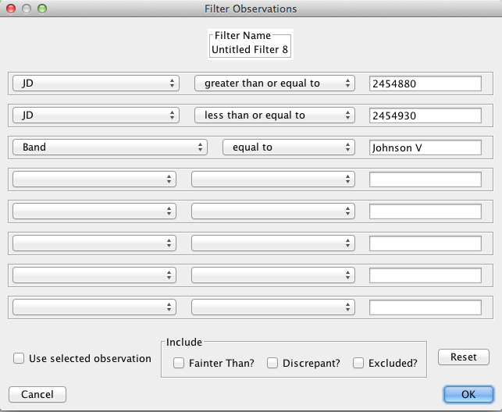

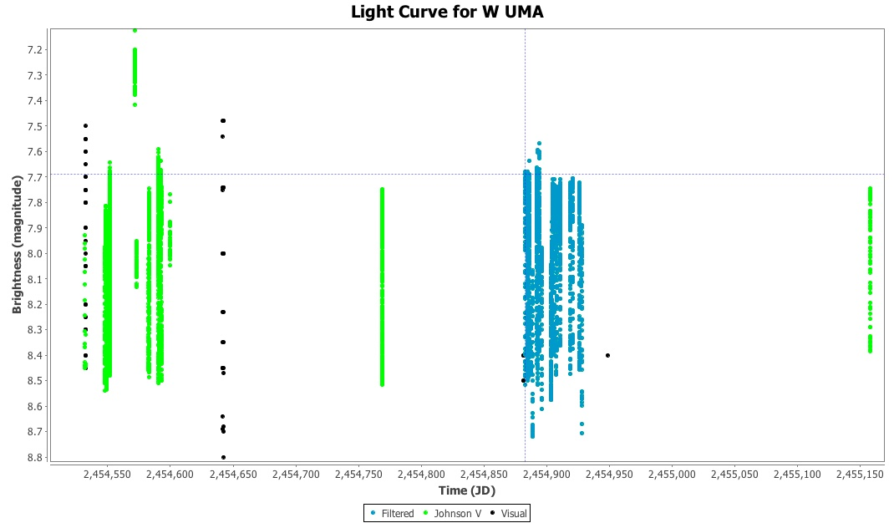

Note that the “Filter Name” text box at the top of the observation filter dialog can be modified to give a filter a meaningful name, e.g. “2454880...2454930 V.”

A filter series can be hidden from view just like any other series, via the Plot Control Dialog. The current filter can be completely removed by selecting View → No Filter.

Previously created filters for the currently loaded dataset can be retrieved and viewed by selecting View → Previous Filters...

Filters can also be deleted and new series can be created from them, to be treated just like any other series in the Plot Control Dialog, preferences and so on. Each filter has a description that can be viewed via the Show Description button.

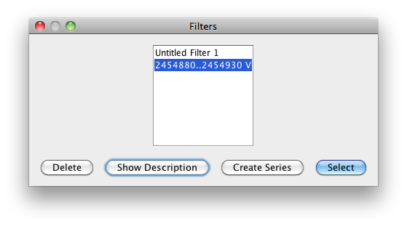
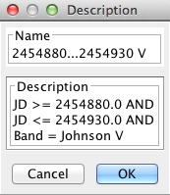

The second method of creating an observation filter is via an Observation List selection filter. The following observation list screenshot shows a pattern search (see Observation List section) being used to narrow down observations to just Johnson V (this could also have been done via the Plot Control dialog) and a selection (via shift + mouse-click) of multiple observations.
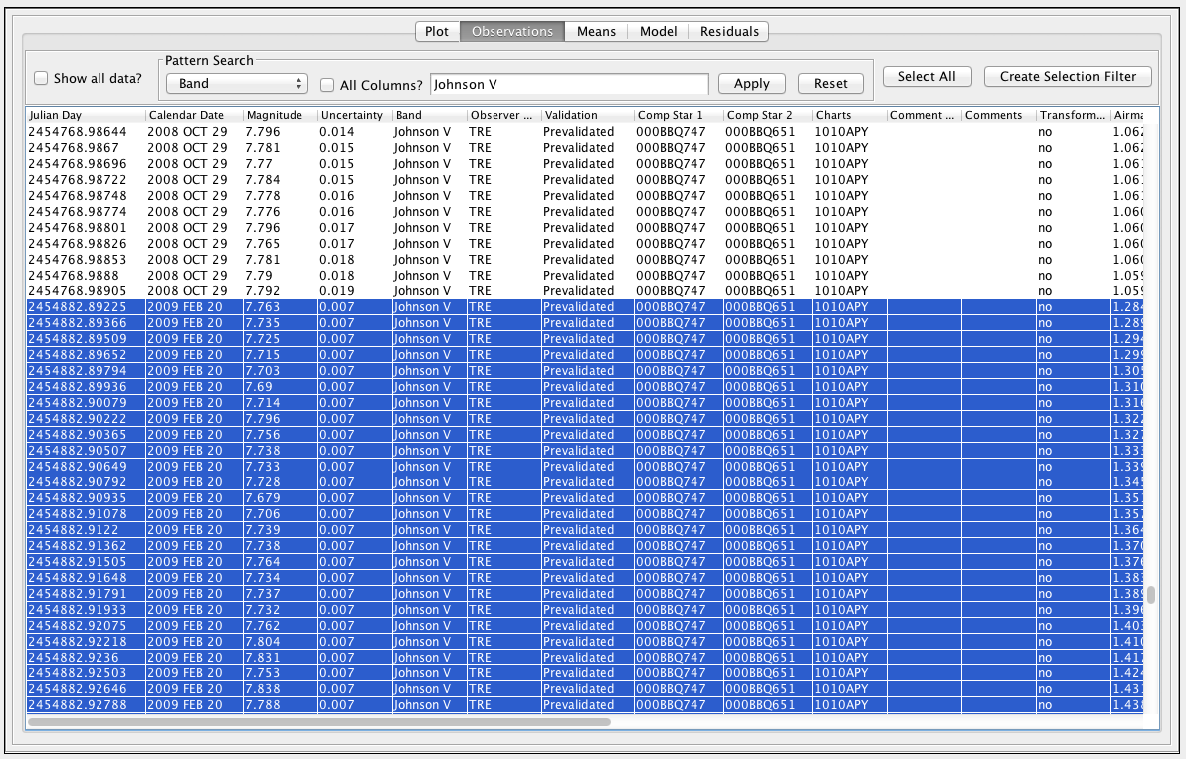
Clicking the Create Selection Filter button would yield the same filtered subset as above (assuming the end date was appropriately selected). Note that the Select All button is useful for selecting all observations currently in view in order to create a selection filter.

Selecting View → Filter From Plot creates a filter from the observations currently visible in the raw mode plot.

Selecting View → VeLa Filter... opens the VeLa (see Glossary) filter dialog. The figure below shows a VeLa filter that creates an R Car observation subset conforming to the filter expression shown: transformed V or B observations with a time (JD) greater than 2457600 and any observer code other than the author's:

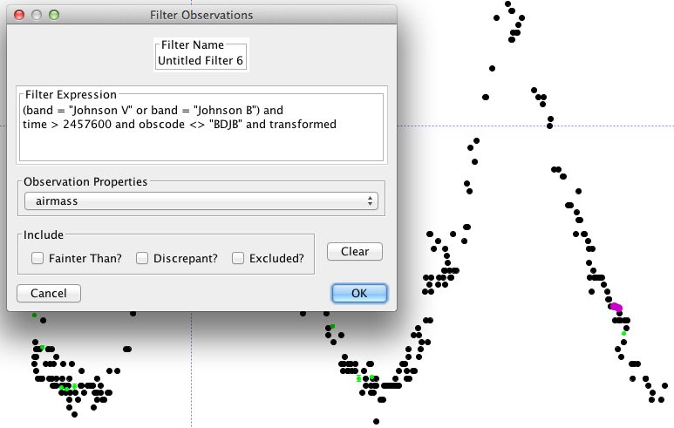
A drop-down menu provides a list of possible observation properties.

Note that descriptions in the Previous Filters dialog for simple and selection filters are also VeLa expressions so may be used as the starting point for more complex VeLa filters.

For more information about the VeLa language, see https://sourceforge.net/p/vstar/wiki/VeLa

See the Plug-ins section for details of custom filters, also available in the View menu.

